**UNBYPASSED EMITTER**

Calculate the following:

V1 = 50mV

VB, VE, IE, IC, VRC, VC, VCE, Zin, Zout, AV, Vout

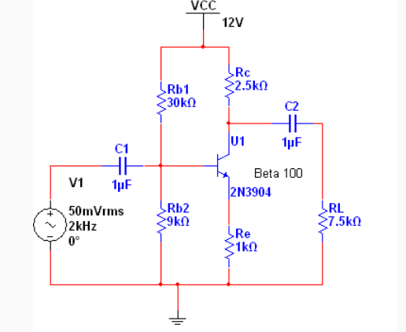

Step1 – Write down what the problem gives you.

Step2 – Calculate VRb2 = VCC*(Rb2/(RB1 + RB2)

Step 3 – Calculate VE = VRb2 - .7

Step 4 – Calculate IE = VE/Re

Step 5 – Calculate VRC = IE * RC

Step 6 – Calculate VC = VCC – VRC

Step 7 – Calculate VCE = VC - VE

Step 8 – Calculate r’e = .025/IE (AC impedance)

Step 9 – Calculate re = r’e + Re (AC impledance

Step 10 – Calculate rc = RC||RL (AC impedance)

Step 11- Calculate AV = rc/re

Step 12 - Calculate Vout = AV * Vin

Step 13 - Calculate the maximum output swing voltage = 2*VCE

Step 14 - Calculate Zin = Rb1||Rb2||B*re (AC impedance)

Step 15 - Calculate Zout = Rc (AC impedance)

**BYPASSED EMITTER**

Calculate the following:

V1 = 50mV

Calculate: VB, VE, IE, IC, VRC, VC, VCE, Zin, Zout, AV, Vout

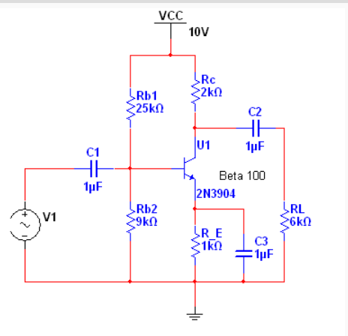

Step1 – Write down what the problem gives you.

Step2 – Calculate VRb2 = VCC*(Rb2/(RB1 + RB2)

Step 3 – Calculate VE = VRb2 - .7

Step 4 – Calculate IE = VE/RE

Step 5 – Calculate VRC = IE * RC

Step 6 – Calculate VC = VCC – VRC

Step 7 – Calculate VCE = VC - VE

Step 8 – Calculate re = r’e = .025/IE (AC impedance)

Step 9– Calculate rc = RC||RL (AC impedance)

Step 10 Calculate AV = rc/re

Step 11 Calculate Vout = AV * Vin

Step 12 Calculate the maximum output swing voltage = 2*VCE

Step 13 Calculate Zin = Rb1||Rb2||B*re (AC impedance)

Step 14 Calculate Zout = Rc (AC impedance)

**SPLIT EMITTER**

Calculate the following:

V1 = 50mV

VB, VE, IE, IC, VRC, VC, VCE, Zin, Zout, AV, Vout

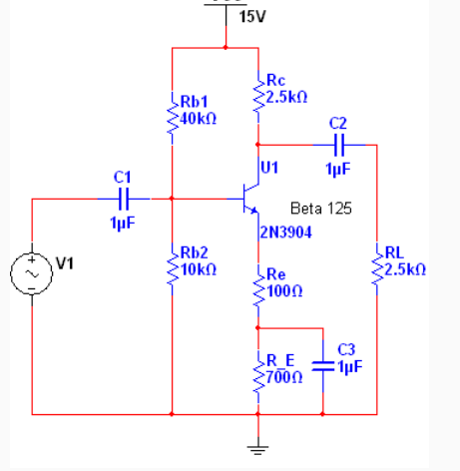

Step1 – Write down what the problem gives you.

Step2 – Calculate VRb2 = VCC*(Rb2/(RB1 + RB2)

Step 3 – Calculate VE = VRb2 - .7

Step 4 – Calculate IE = VE/(Re +RE)

Step 5 – Calculate VRC = IE * RC

Step 6 – Calculate VC = VCC – VRC

Step 7 – Calculate VCE = VC - VE

Step 8 – Calculate r’e = .025/IE (AC impedance)

Step 9 – Calculate re = r’e + Re (AC impledance

Step 10 – Calculate rc = RC||RL (AC impedance)

Step 11- Calculate AV = rc/re

Step 12 - Calculate Vout = AV * Vin

Step 13 - Calculate the maximum output swing voltage = 2*VCE

Step 14 - Calculate Zin = Rb1||Rb2||B*re (AC impedance)

Step 15 - Calculate Zout = Rc (AC impedance)\